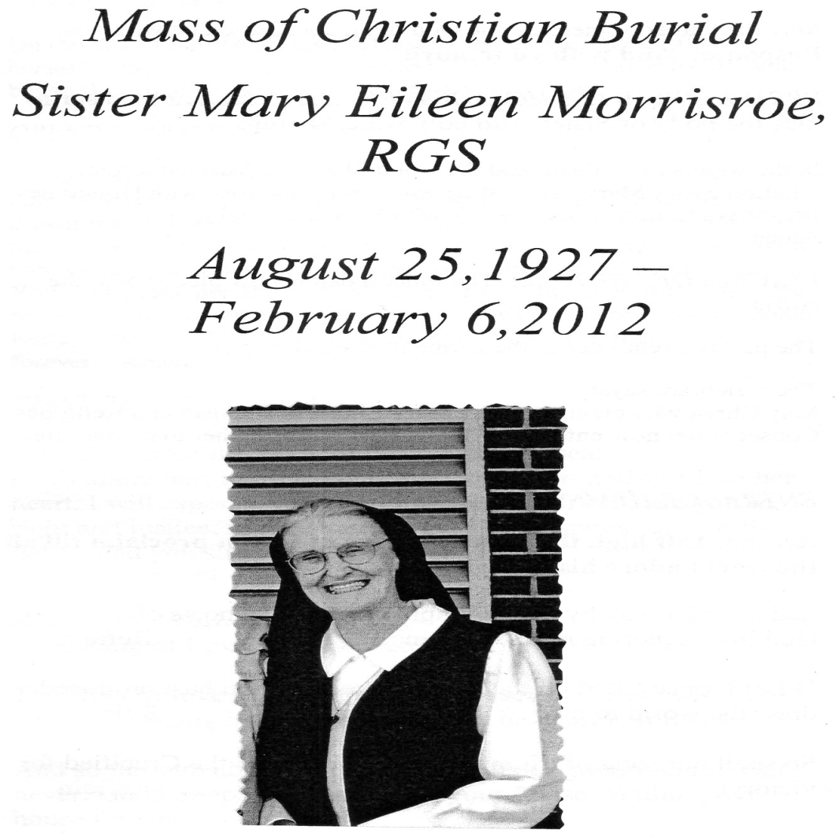

Sr. Eileen Morrisroe , Good Shepherd Sister lived in Marymount for a number of years. She remained a dear friend to many.
This is an except from her Superior Sr. Nora sent to Jacqueline Webb informing her of Sr. Eileen’s death.
“Dear Jackie,
Our dear friend Sister M. Eileen is with our Shepherd God! She died so peacefully – slipped away after we prayed Office, Rosary, sang her favourite songs and prayed the Divine Mercy Chaplet. I was with her all day, held her hand and talked about people we both knew in New Orleans and Memphis.
It was the last two hours she seemed to know I was there and responded by blinking her eyes.
Thank you so much for your correspondence and interest in how she was doing. Her family will have a Memorial Mass in Oakland, California. She is buried here with us in Baltimore.
In our Shepherd’s Heart
Sister Nora Pat “
Sr. Eileen was missioned to Indonesia in the early 70s where she worked among the students in the school –‘Baranangsiang’ in Bogor.
In 1977 she came to Singapore and was part of the Novitiate Community in what was then called ‘Nazareth-Ville’. She organised camps and retreats for the students of Marymount Convent School. .
Sr. Eileen started the Charismatic Prayer Group in Risen Christ. As Jacqueline recalls ‘she agreed on one condition that we were not going to be ’Holy Rollers’, only giving in to our emotions and singing ‘catchy tunes and getting hysterical when singing in tongues. She wanted us to listen carefully each week to what the Holy Spirit is saying to each one of us”
Today Risen Christ Prayer group has grown to a vibrant and alive group touching many with the power of the Spirit. How proud she must be now as she is embracing the fullness of the Lord.
In 1978 she joined the Marymount Community and continued her apostolate in the school?
Her infectious smile captivated many a sorrowing heart binging peace and calm in the midst of pain and anguish.
She returned to the States in the late 70s and kept in touch with many here in Singapore.
Many of us would be interested to know how Sr. Eileen spent her last few years in the States.
Jacqueline Webb sent me this letter which many of you will would like to read.

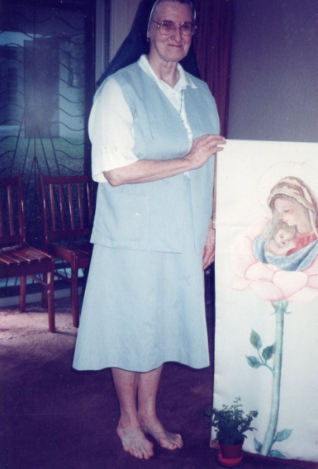
Sr. Mary Eileen –
Marymount 1977

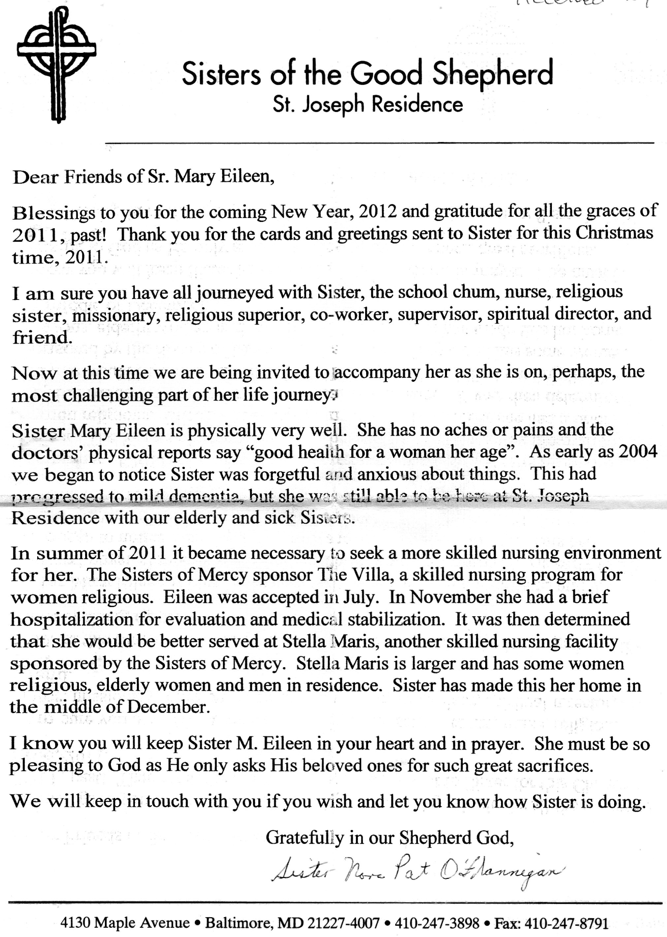
May our dear Sr. Eileen rest in peace.
Sr. Gerard Fernandez rgs Good Shepherd Sunday 2012

